**Want to quit smoking?**

**Self refer via:** **yhbolton.co.uk/sign-up/**

**Your Health Bolton** is here to support you.

Quitting smoking is one of the best things you can do for your health, no matter your age or how long you’ve smoked.

Smoking damages your lungs, heart, and other vital organs, and increases your risk of serious health conditions such as cancer, stroke, and heart disease.

If you’re ready to quit smoking, we’re here to help. Our team of experts can provide you with the tools, support, and guidance you need to kick the habit for good.

Flexible times and venues in Bolton. Easy access to stop smoking medication. Nicotine replacement therapy. Drop in Sessions. Telephone Support

yhbolton.co.uk

**Community classes/Support groups**

Please see our community board at the front door for details of local classes and support groups

**STABLE FOLD SURGERY NEWSLETTER SUMMER 2024**

**Staff (ST2 GP)**

Dr Nasarullah will be ending his time with us towards the end of July 2024. We wish him every success in his career. Dr Kirsten Lee will then join us in August 2024

**Website: Stablefoldsurgery.co.uk**

**Email:** [**gmicb-bol.p82005@nhs.net**](mailto:gmicb-bol.p82005@nhs.net)

**Tel: 01942 813678**

**Suggestions**

If you have any suggestions for the improvement of the practice, please complete a slip and leave in the suggestion box which is next to the Reception window in the waiting room

Thank you

**Pharmacy First**

You can now attend your Pharmacy without seeing the Doctor, for the following:

|  |  |
| --- | --- |
| **Symptom** | **Age Range** |
| Acute otitis media/ear infection | 1 to 17 years |
| Impetigo | 1 year and over |
| Infected insect bites | 1 year and over |
| Shingles | 18 years and over |
| Sinusitis | 12 years and over |
| Sore throat | 5 years and over |
| Urinary tract infection | Women 16-64 years |

**Contacting 111**

At times the Health Navigators may direct you to call 111 when we have no appointments available. NHS 111 can make direct appointments with a variety of health services including GPs, some Mental Health Services and Urgent Treatment Centres

This practice has a contractual obligation that states we must provide GP appointments for 111 to book patients into, so several appointments are saved to allow 111 to book patients in, on a daily basis

**Practice Email**

We do NOT accept requests for appointments via our practice email address. Please contact Reception via telephone, book online or present at the front desk

**One Appointment, One Problem**

When booking an appointment, please ensure that it is to discuss one problem only. Discussing more than one problem in the appointment time allocated means that there is a real increased risk that mistakes could be made, as the clinician may be inclined to rush. We are working with your best interests to keep you safe.

Please do not be offended if you are asked to rebook for your other problems. If you have multiple problems to discuss, please consider booking a double appointment so that adequate time can be given.

**Holiday Vaccinations**

If you require any vaccinations relating to foreign travel, please collect and complete a travel vaccination form and return it to Reception.

The Practice Nurse will contact you to discuss your travel arrangements.

This will include which countries and areas within countries that you are visiting to determine what vaccinations are required.



**Prostate Cancer-Check your risk**

*1 in 8 men will get prostate cancer. If you’re over 50, or you are of black origin, or your dad or brother had prostate cancer, you are at an even higher risk.

Prostate cancer is not always life-threatening but when it is, the earlier you catch it, the more likely it is to be cured

Visit: <https://prostatecanceruk.org/risk-checker>

*Prostate cancer uk

**Bolton Hive**

The Health Hive-Market Place

Knowsley Street, Bolton BL1 2AL

01204 916241

**Blood tests:**

This service is available Tuesday to Thursday 10am till 4pm

**Cervical smears:**

They also provide a smear taking service-no appointment necessary

Walk in Cervical Screening 10am-4pm

**\*GPs Are On Your Side**

If you have lost your family doctor, you are not alone. General Practice is broken. Help us fix it.

You have probably noticed that something is wrong. Look at the difficulty you have in getting an appointment at your local surgery. When you do get through, it may not be an appointment with a GP at all. Have you lost your regular family doctor? You are not alone. The past decade has seen us lose far too many surgeries and thousands of GPs.

**General Practice is collapsing. Every practice across England is struggling to keep its doors open.**

We value our patients. We know that most patients value us too, especially when they need us regularly. You know we can deal with most of your health problems, keep you out of hospital, and have your best interests at heart. The problem is with the mismanagement of the NHS.

Your GP is an expert in general medical practice – trained over 10 years to deal with complex problems, spot serious symptoms, and decide when you need specialist help at the hospital.

We believe general practice deserves a bigger slice of NHS funding so we can train and hire more GPs, deliver the services you require and make it easier for you and your loved ones to get appointments to see your GP and practice team.

GPs want the same things that you do. We believe nobody should struggle to see their family doctor.

General Practice should be as it once was – a familiar family doctor, offering continuity of care in a surgery full of friendly familiar faces within a safe building where you knew you would get the care you needed.

**How can you support your family doctor?**

**Talk to any election candidate who you come across**

**When candidates from the political parties come knocking on your door, ask them what they will do to save general practice. What will they do so you can see a GP in a modern local surgery?**

*https://www.BMA.org.uk

**TESTICULAR CANCER AWARENESS**

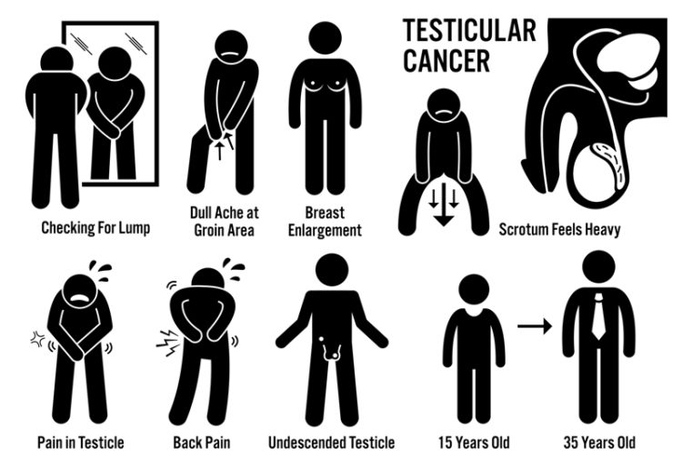

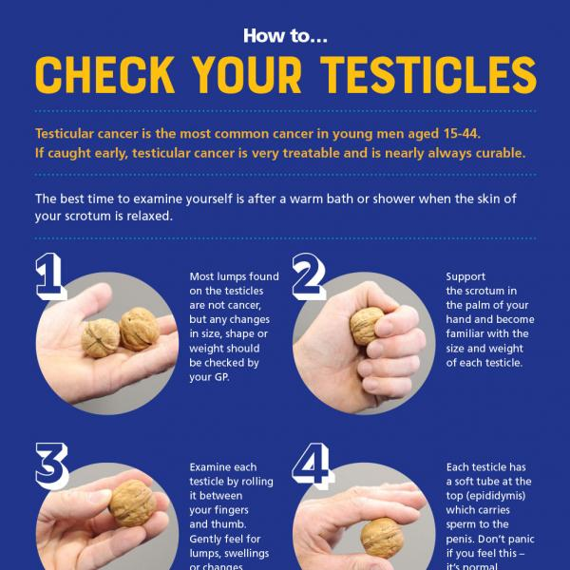

**Routine Appointments**

Visit our website and fill out the online consult form at

<https://www.online-consult.co.uk/org/stable-fold-surgery>

We will then contact you within the following 2 working days, with advice or a future appointment time

**Practice Car Park**

Please be mindful when using the practice car park.

**Spaces are limited and are for use by patients, visitors and staff who are** **attending the practice, on the day**



**Opening Times**

**Opening Hours (Door closes 6.00PM)**

Monday 8.00AM-6.30PM

Tuesday 8.00AM-6.30PM

Wednesday* 7.30AM-6.30PM

Thursday* 7.30AM-6.30PM

Friday 8.00AM-6.30PM

**When we are closed:**

Out of Hours Service 0161 763 8940

NHS 111 111

Leigh Walk in Centre 01942 483 453

*Patients cannot book appointments until 8.00AM on these days

**Extended Primary Care**

Appointments are offered at Unsworth Group Practice (Peter House Surgery) Captain Lees Road Westhoughton BL5 3UB. The hours are Mon-Friday 6.30PM-9.30PM and Saturdays 9AM-5PM.

We offer multiple clinicians such as

Doctors

Nurses

MSK (Physiotherapy)

Mental Health Practitioners

If these appointment times would suit you better please ring the surgery for our availability.

These appointment are pre-bookable.